***How to build?***

***Hardware Requirement***

* ESXi 5.X host with

1. At least 16 cores
2. 16GB RAM
3. At least 100GB free space on datastore

* Enable promiscuous mode on physical ESXi(Not needed if you don’t want you VM’s in virtual setup to access to public network)

*(You can* ***skip*** *steps 1 to 3 if you don’t want to access public network from any of VMs on virtual ESX host. If you aren’t sure right now just follow 1 to 3 steps)*

1) Login to your vSphere client->select your ***physical ESXi host***->click on Configuration tab -> click on Networking and click on properties

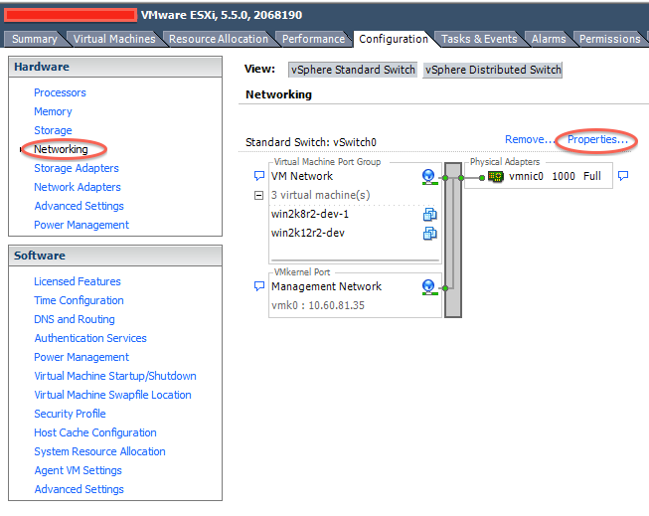

2) After you do step 1 following window will open. If promiscuous mode is Accept then ignore this step otherwise click on Edit

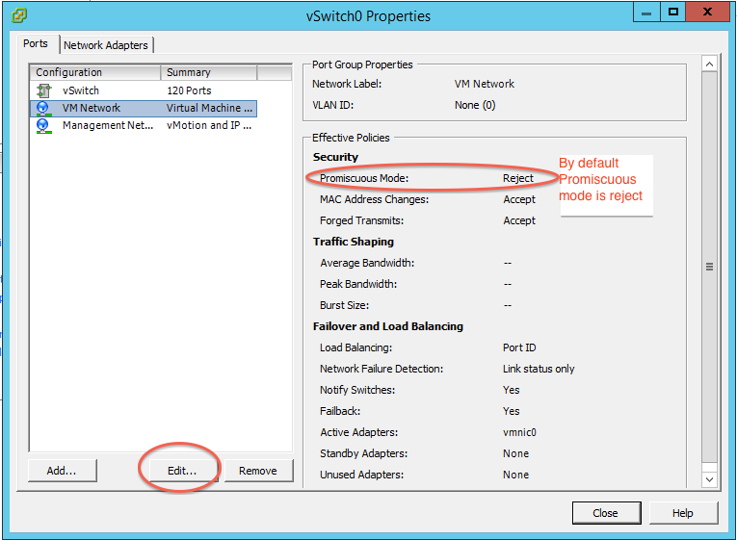

3) On next window select Security tab and change promiscuous mode to Accept and click OK

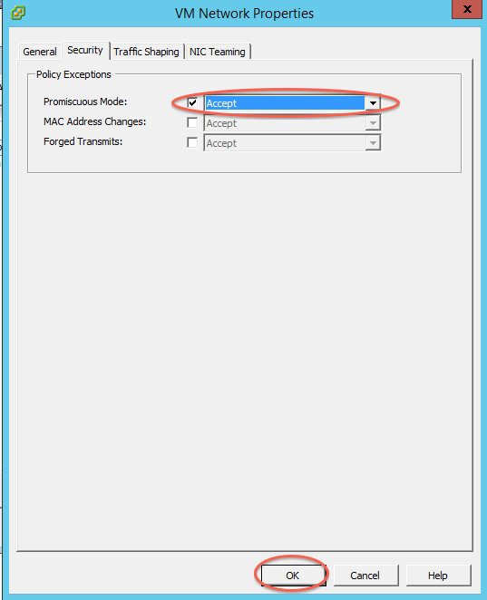

* Install ESXi on VM <http://www.virtuallyghetto.com/2012/08/how-to-enable-nested-esxi-other.html>

Create new VM (This will be our virtual ESXi VM)

1. Name VM, Click Next > (I am not attaching all screen shots, wherever you don’t see screen shot assume you have to select default)

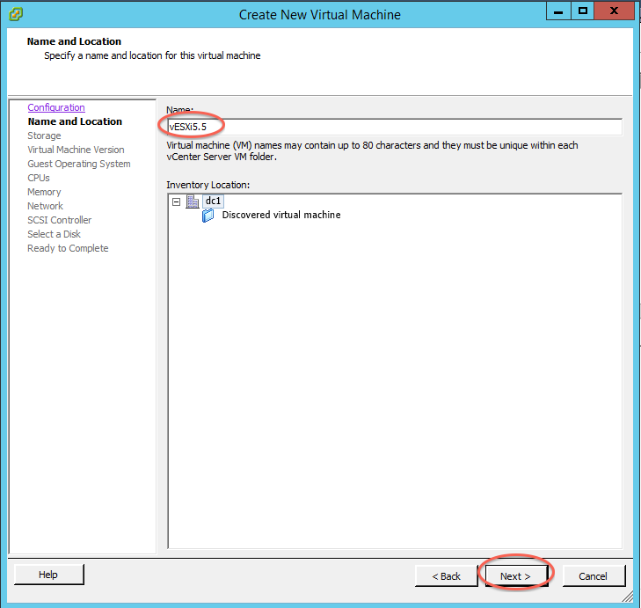

1. Select VM Ware version 8 (latest) and click Next >

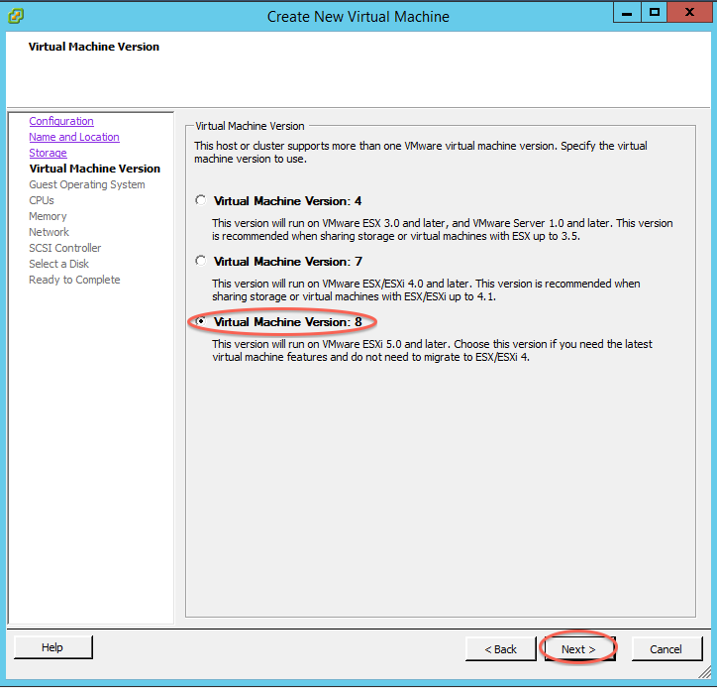

3) Select operating system as “Other” and version as “Other (64-bit)”

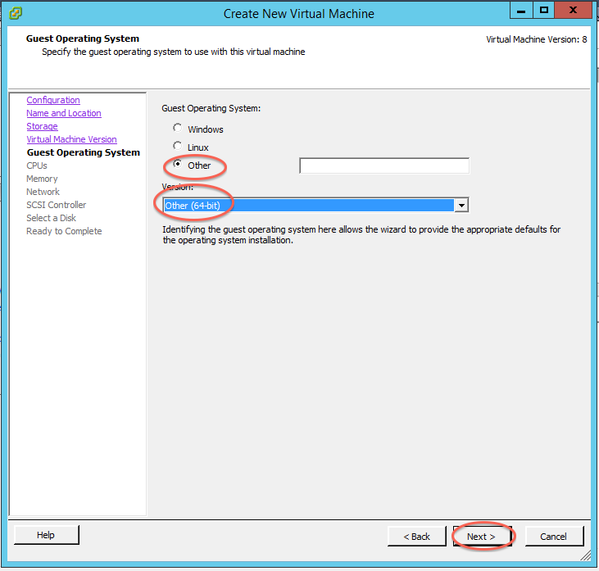

4) Select only one NIC and click Next >

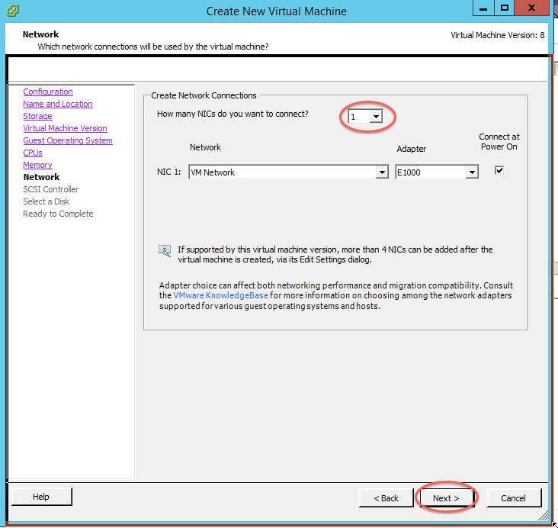

5) Give virtual disk size to be 100G(Space you need depends on number of VMs you want to put on CSV)

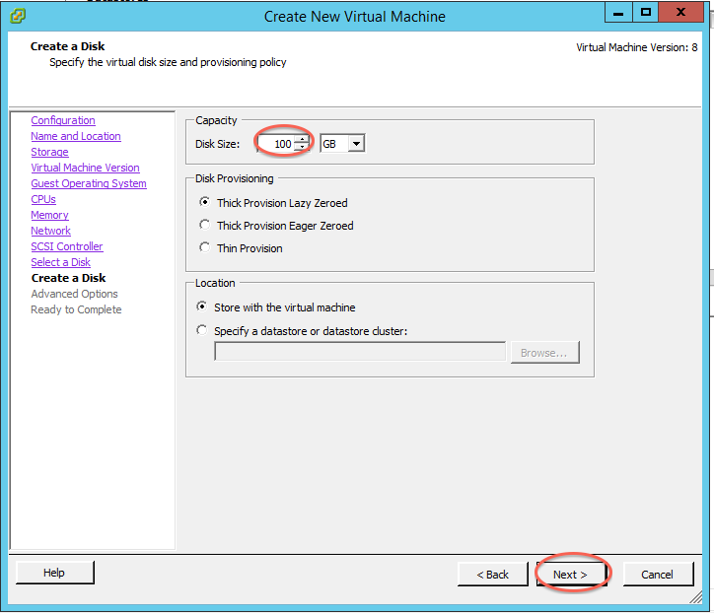

6) To install virtual ESXi VM please select virtual machine settings and provide ISO path.

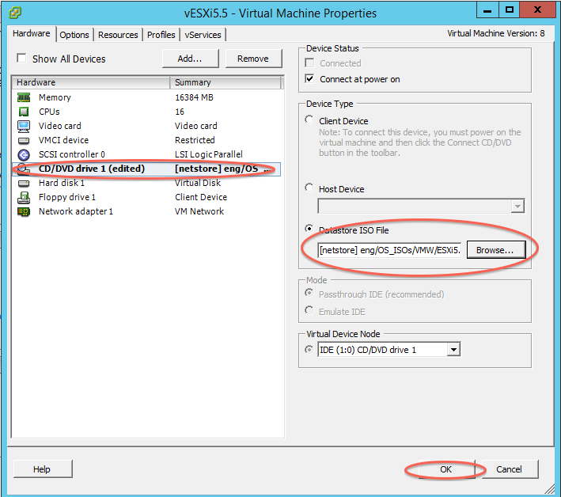

7) In order to change boot priority boot into bios next time:

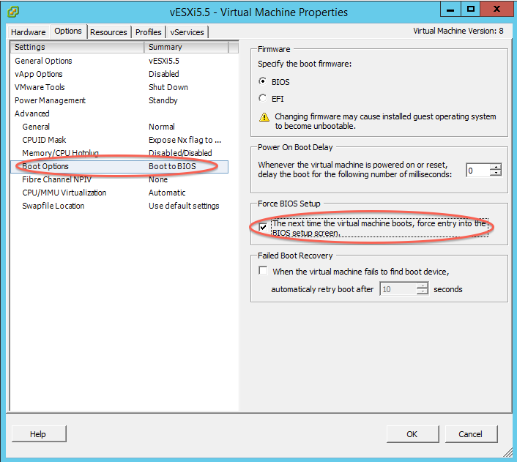

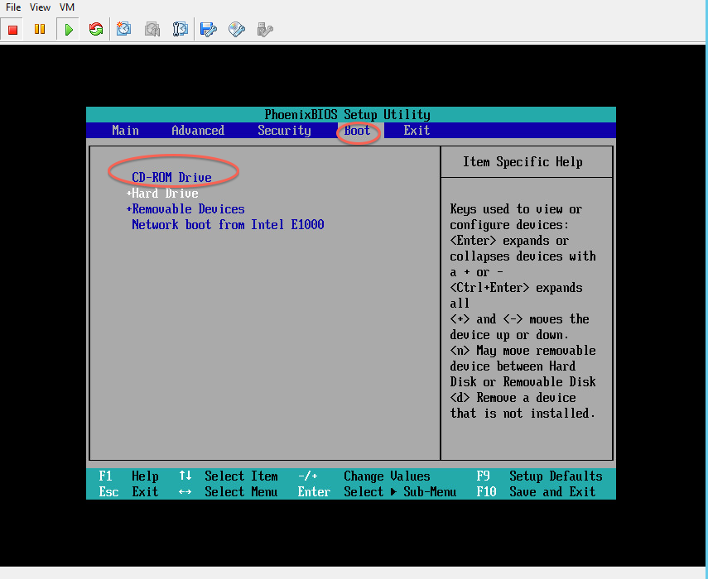

8) Boot from CD

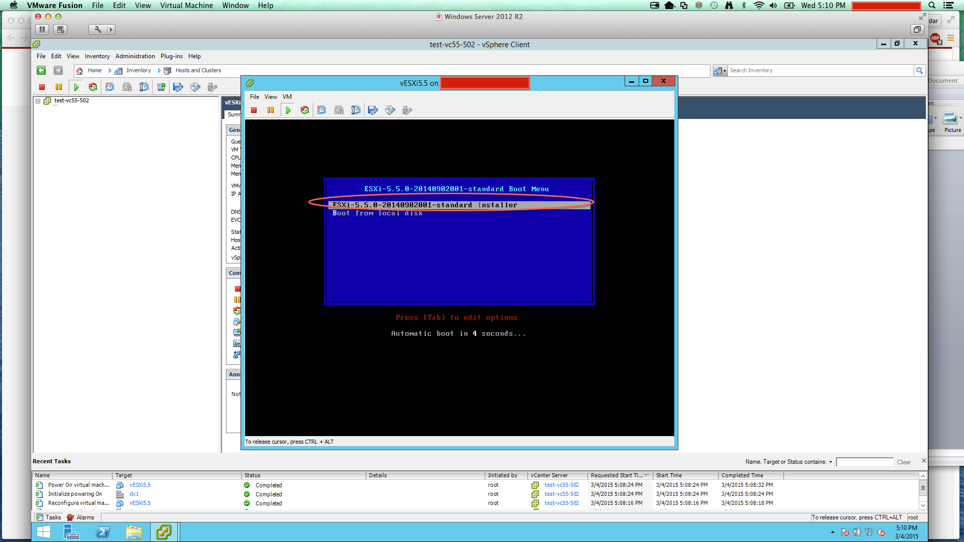

Wait till you see following screen

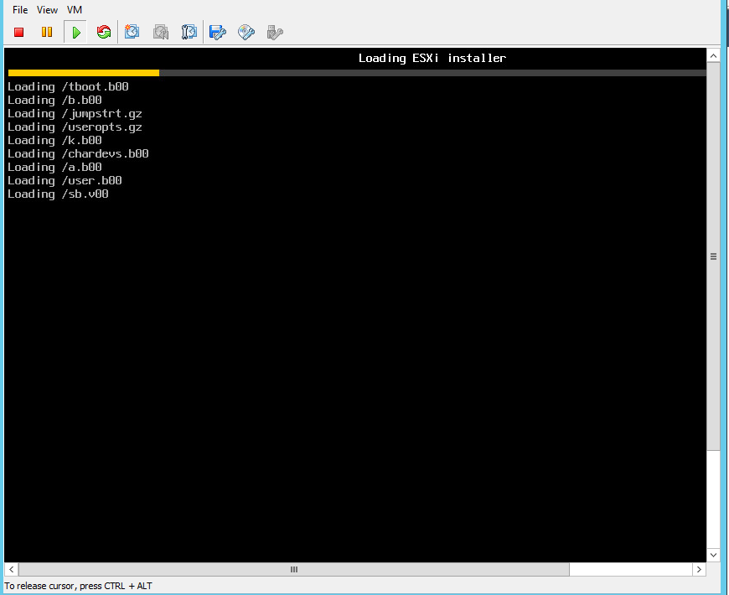

9) Install ESXi

Hit enter when you see following screen

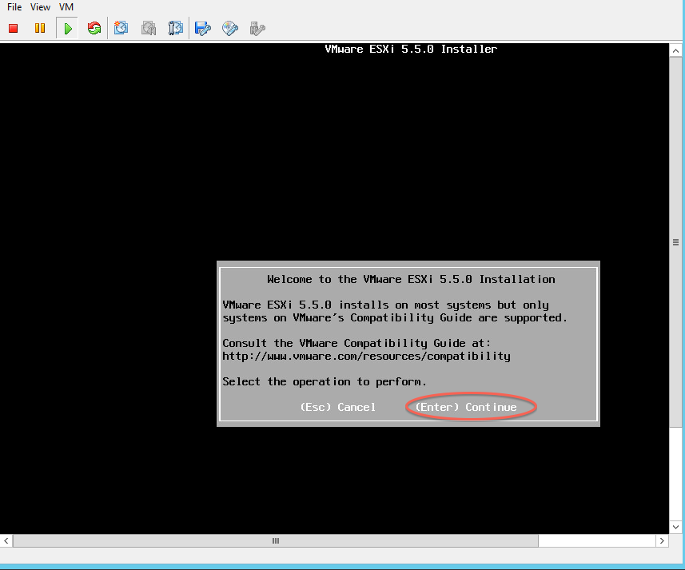

10) Ignore following warning for now

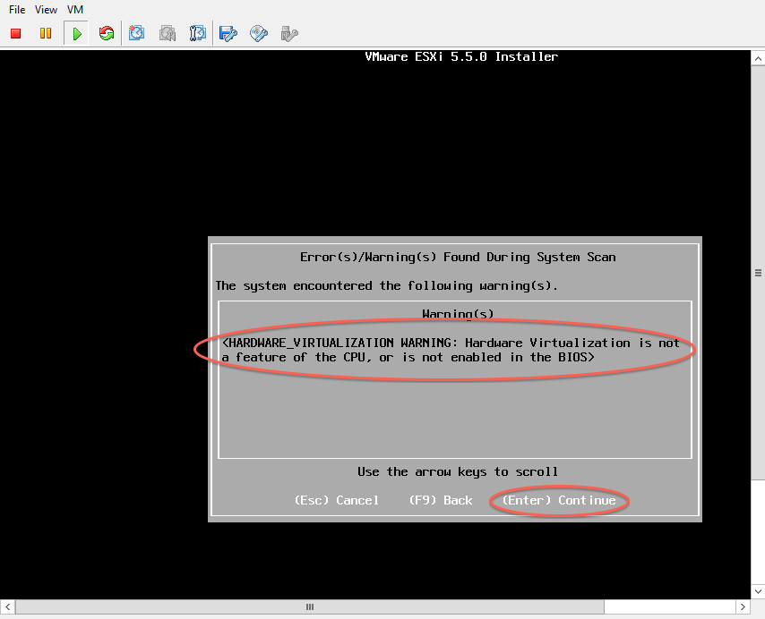

11) Reboot after successful installation

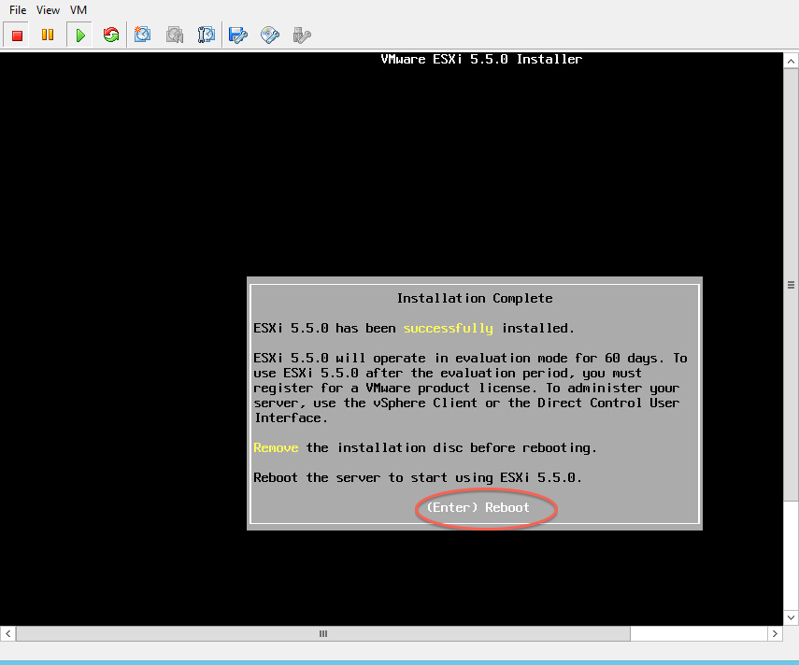

12) Let VM reboot and wait until you see VM has DHCP ip(Reason to have DHCP ip is to make template of this VM which will have 2 hyper-vs and domain controller)

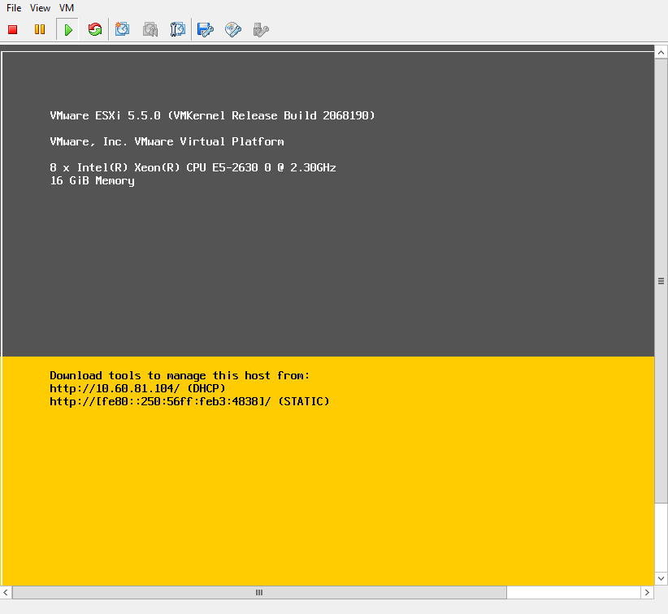

13) In order to make this ESXi vm host other vms we will have to enable hardware assisted virtualization support. To do that we need VM version to be 10. So if it is not 10 already we have to upgrade. You can check your VM version here:

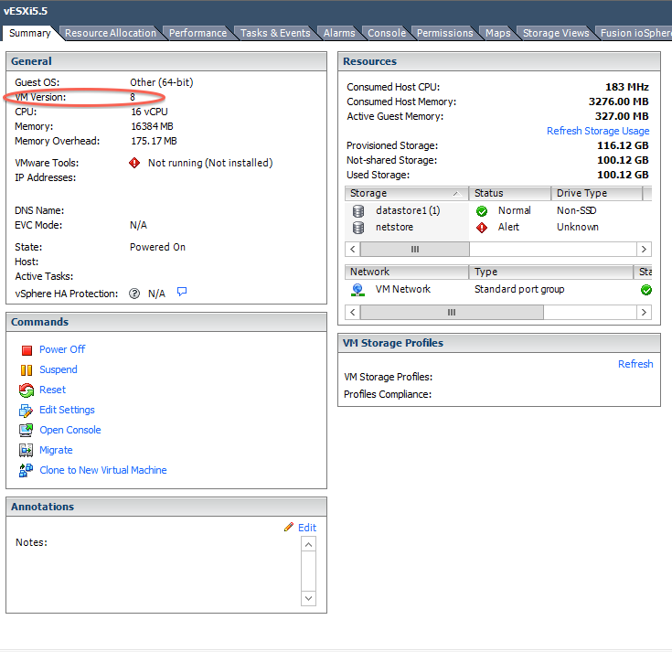

14) Also by logging to Vsphere **web client** you can check if hardware assisted virtualization support is enabled.

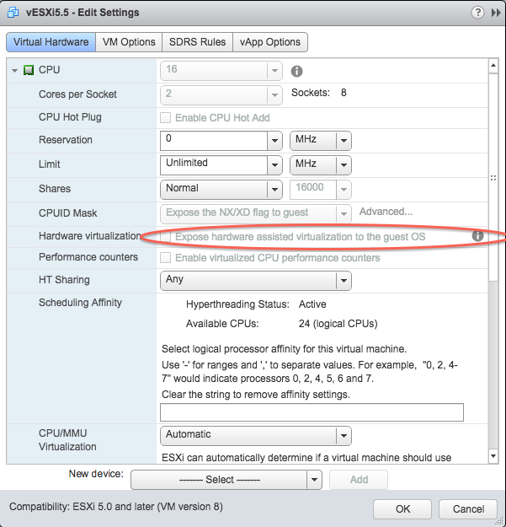

15) If not then power off VM and update VM Version to 10. (Right click on VM and you will see option to upgrade VM)

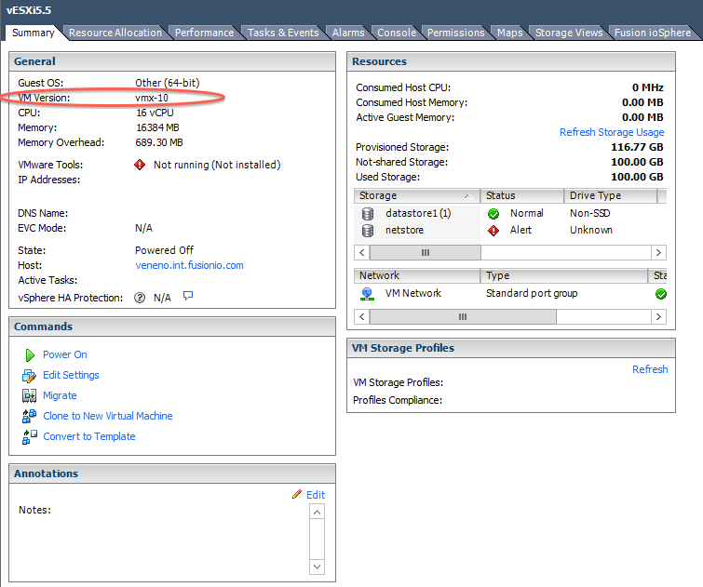

16) Once VM is upgraded power it on, login to VSphere web client and enable hardware-assisted virtualization,

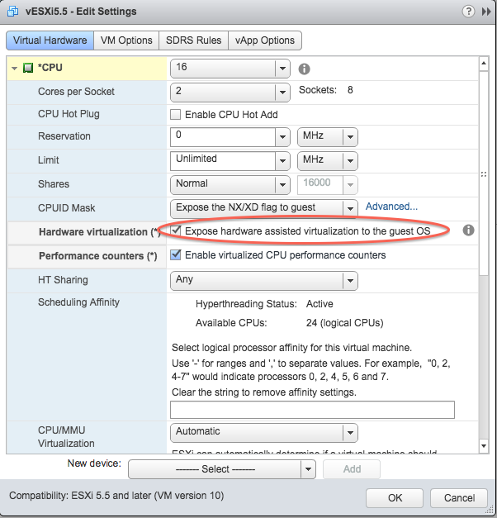

(Enabling performance counters is not necessary; I did for my own experiment)

17) **Create new hyper-v VM on virtual ESXi:**

Follow usual step to create VMs. I will quickly go through these steps (Skipping defaults)

Name VM

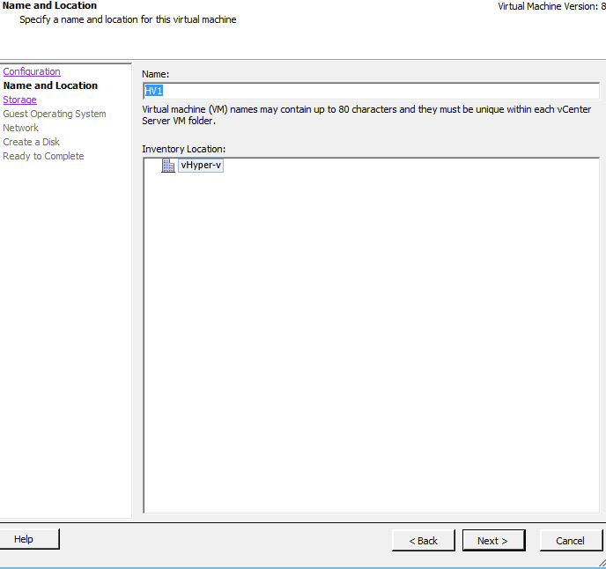

Select operating system details as shown in following image and click next:

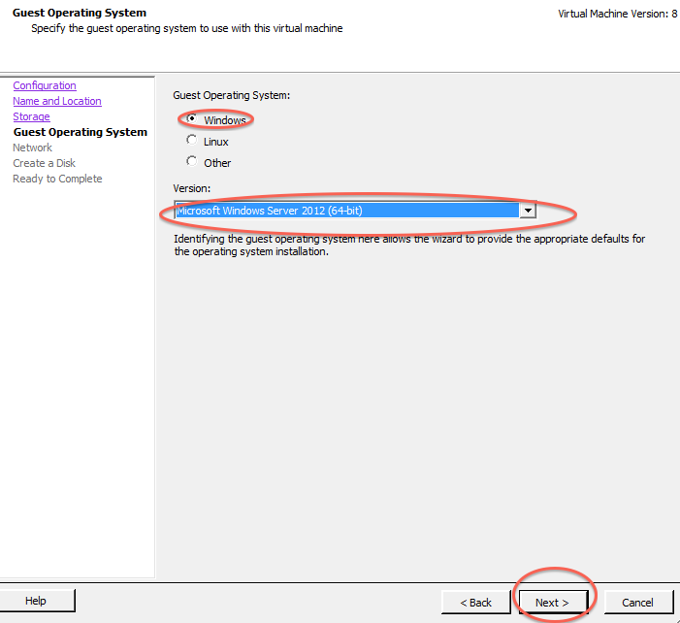

Add 2 nics (One for private network and one for public network):

Select rest of the details as:

Memory 4GB

vCPUS: 4

Hardisk: 16G

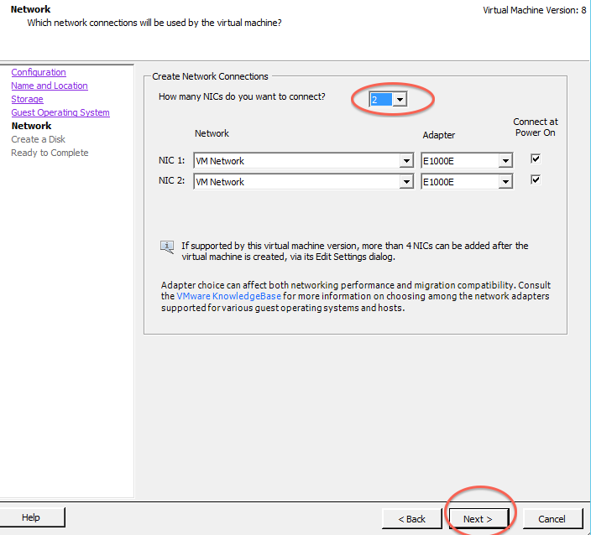

18) Once operating system is installed, login to machine as Administrator and try adding hyper-v role which you wont be able to (This step is to show how error looks like. You can skip to next step if you want).

Open server manager and right click on your server, click Add roles and features,

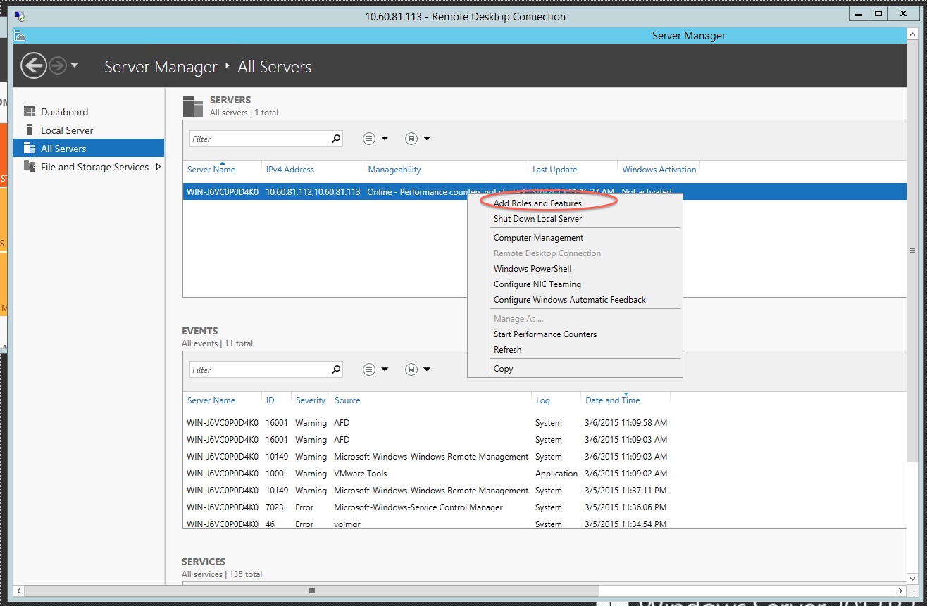

Select “Role based or feature based installation” and click next

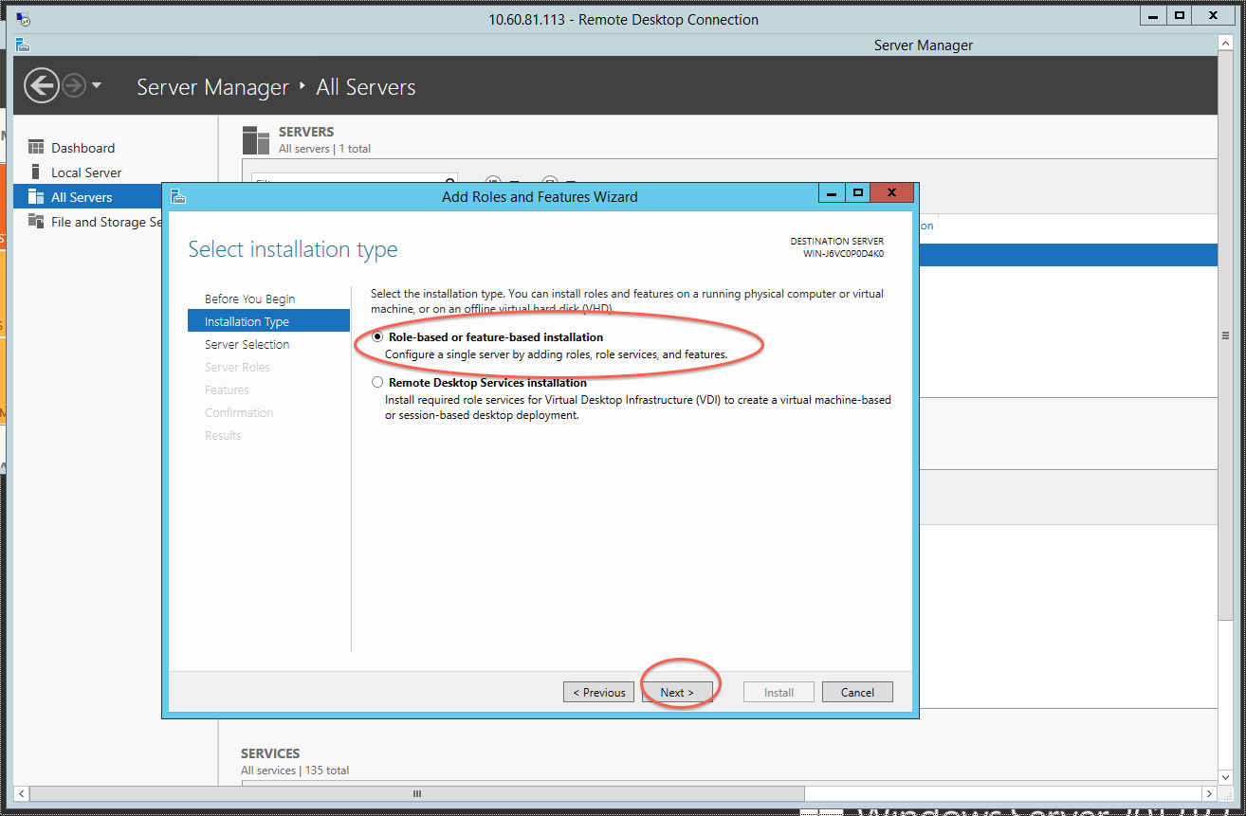

Select Hyper-V and click Next

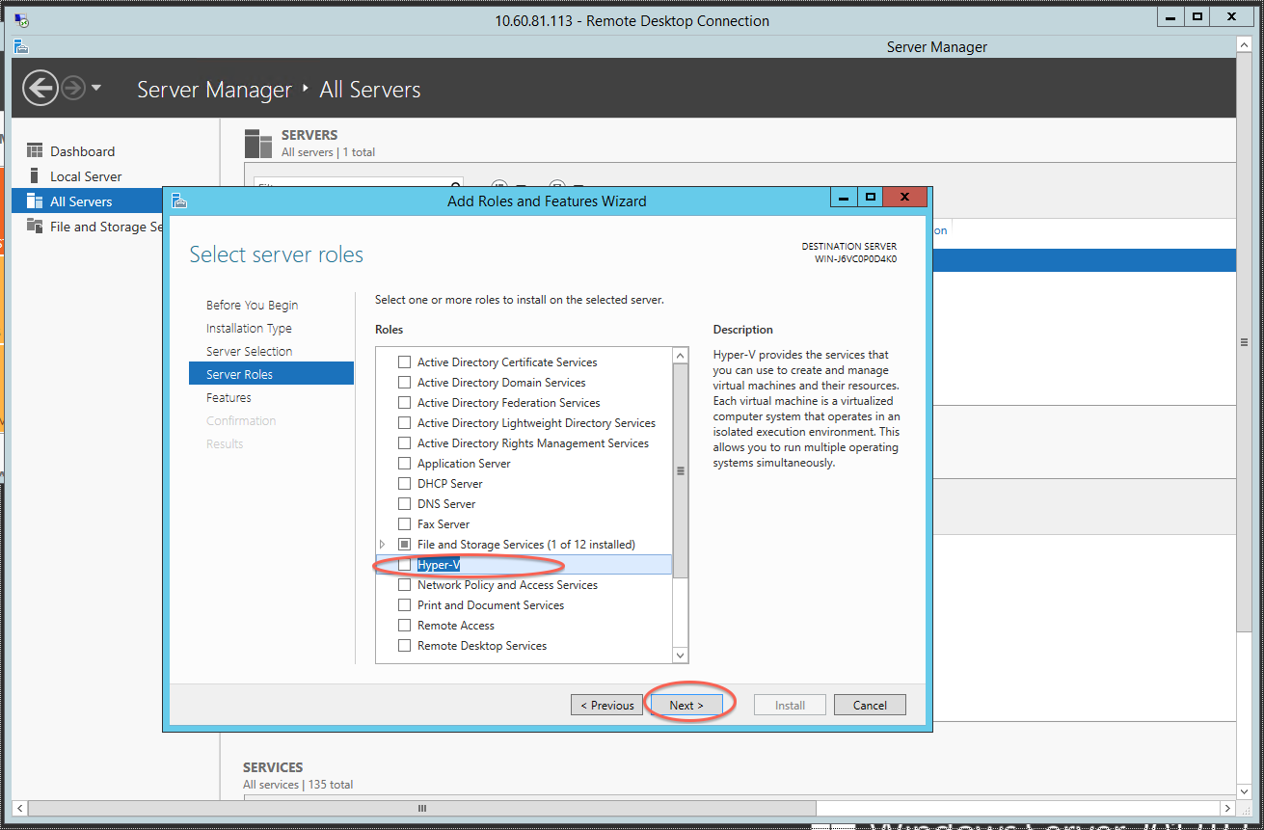

Click “Add Features”

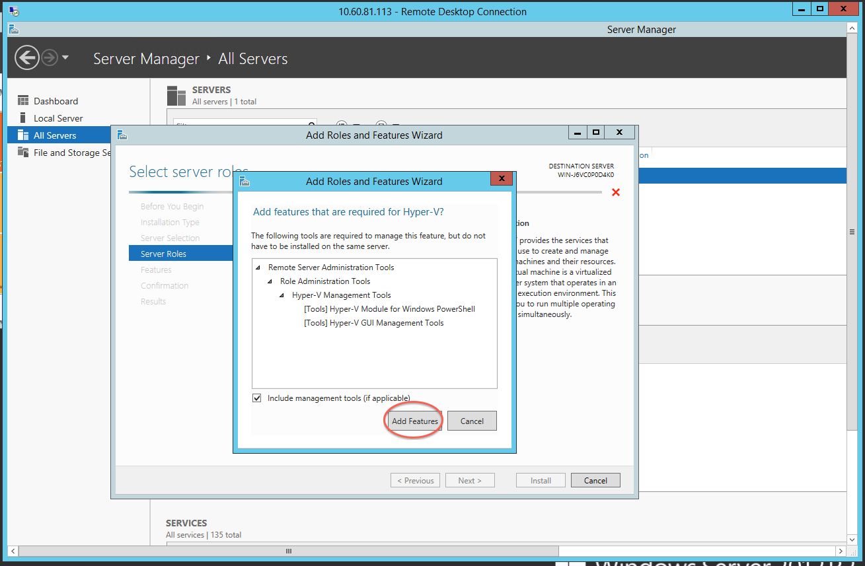

You will get following error (Error is misleading but in short it is saying hyper-v role can’t be added):

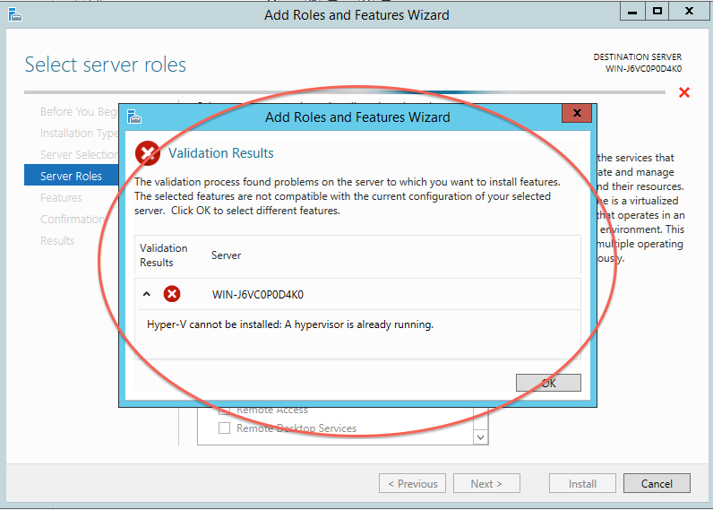

Lets fix this issue,

Shutdown VM and remove it from inventory,

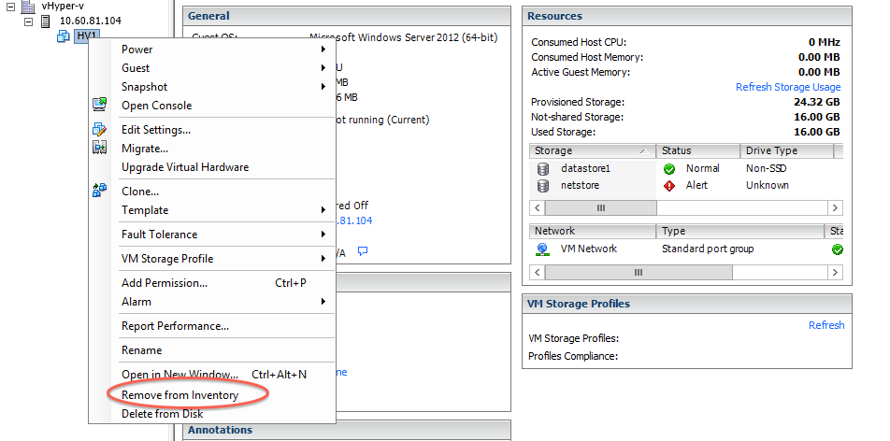

Download the corresponding .VMX file to your computer and open it in WordPad.

Somewhere in the VMX file add the two following lines:

**vhv.enable = “TRUE”**

**hypervisor.cpuid.v0 = “FALSE”**

[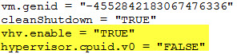](http://cdn.derekseaman.com/wp-content/uploads/2014-06-19_18-59-58.jpg)

If you have upgraded your VM to vHW 10 then you can follow William Lam’s [tip](http://www.virtuallyghetto.com/2013/09/quick-tip-new-hyper-v-guestos.html) and set the guestOS to use to be “windowsHyperVGuest”. If you are using vHW v8 then leave it to default “windows8svr-64″.

[014-06-20_8-03-26](http://cdn.derekseaman.com/wp-content/uploads/2014-06-20_8-03-26.jpg)

Save the VMX file and re-upload it to the datastore, overwriting the old file(Please save old file somewhere before overwriting if in case you need it later).

Right click on the VMX file and register the VM.

(I found this trick from Derek Seaman’s blog <http://www.derekseaman.com/2014/06/nesting-hyper-v-2012-r2-esxi-5-5.html> )

Power on VM and see if you can add hyper-v feature now,

(This time once you select hyper-v, select “Failover Cluster management as well”)

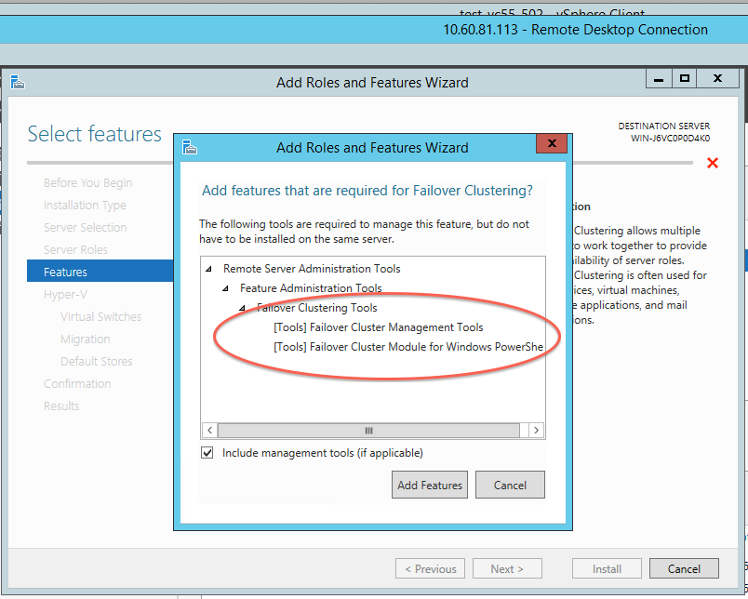

Select Ethernet for cluster (Remmeber we were not able to get to this stage last time before we did Derek’s trick)

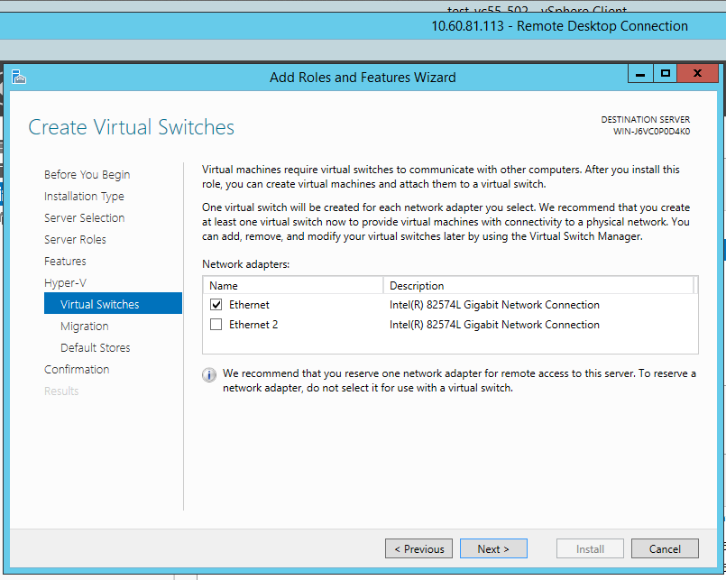

Select live migration if you need (It is necessary for Flashsoft product),

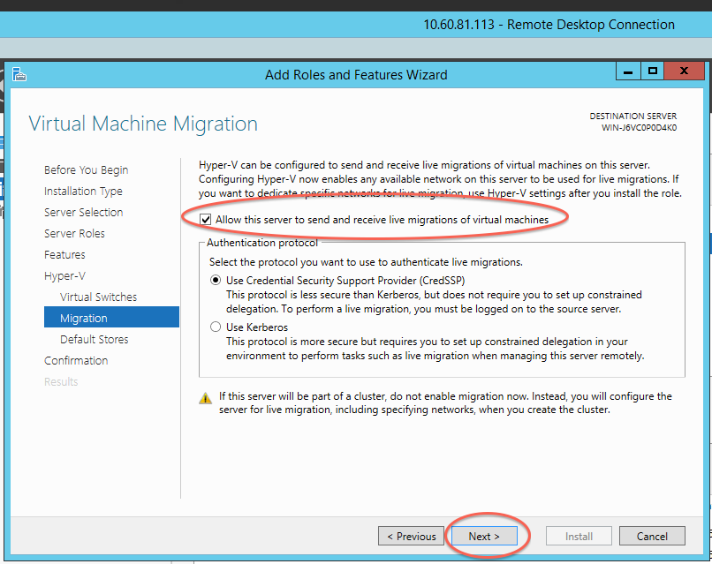

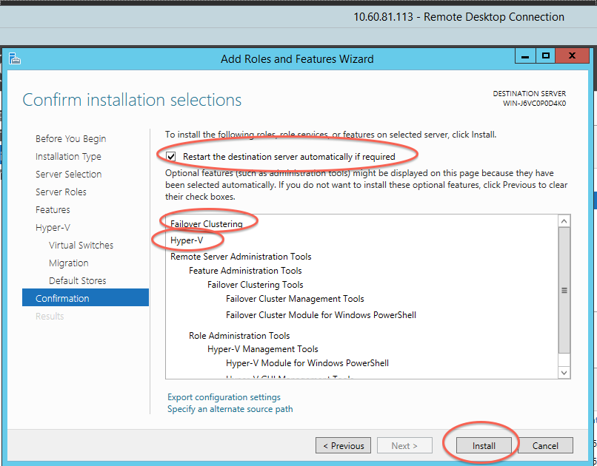

Once you succeed with installation and VM restarts, ***clone this VM for second hyper-v in cluster***. (*If you run into duplicate IP or mac ID issue, remove both nics of cloned VM and add them back again. )*

19) Install domain controller. Rather than me reinventing wheel these are best sources (Make sure you allocate enough space for hard disk on this VM to accommodate CSV volume we are going to use in hyper-vs using iSCSI Software Target. I allocated 32 G):

<http://www.windowsnetworking.com/articles-tutorials/windows-server-2008/Running-Windows-Server-2008-R2-Installing-Creating-Lab-Domain-Controller-Part1.html>

***(Don’t install DHCP if you don’t want to use it)***

<http://www.windowsnetworking.com/articles-tutorials/windows-server-2008/Running-Windows-Server-2008-R2-Installing-Creating-Lab-Domain-Controller-Part2.html>

19) Install iSCSI Software Target on domain controller VM. Click on msi and follow instructions

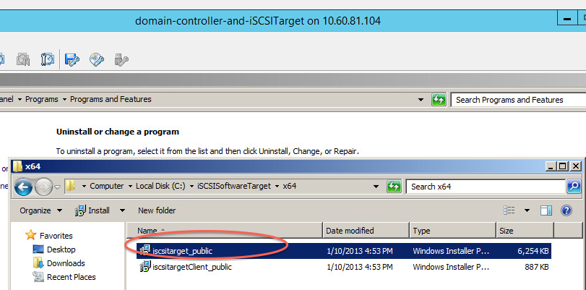

20) Open iSCSI Software Target

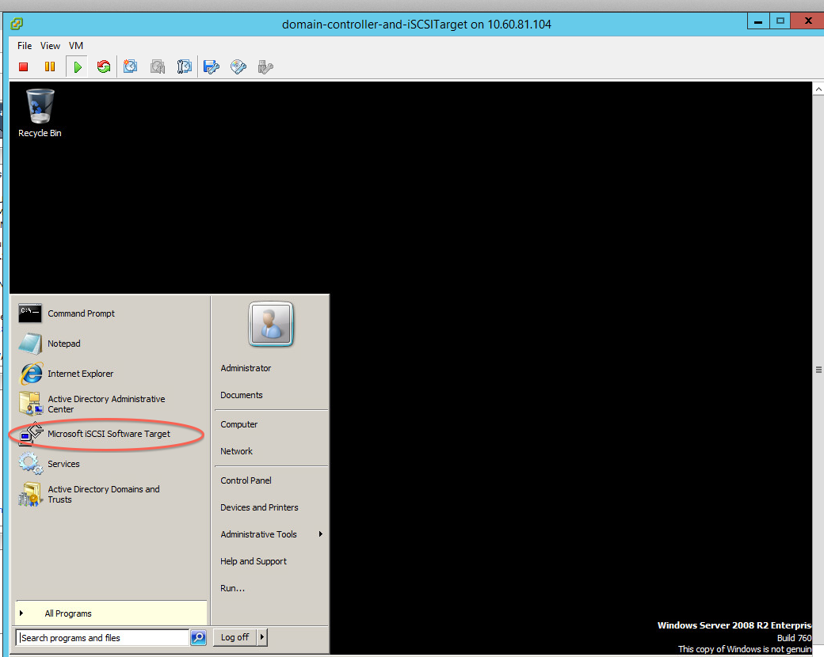

21) Right click on “iSCSI Targets” and select “Create iSCSI Target”

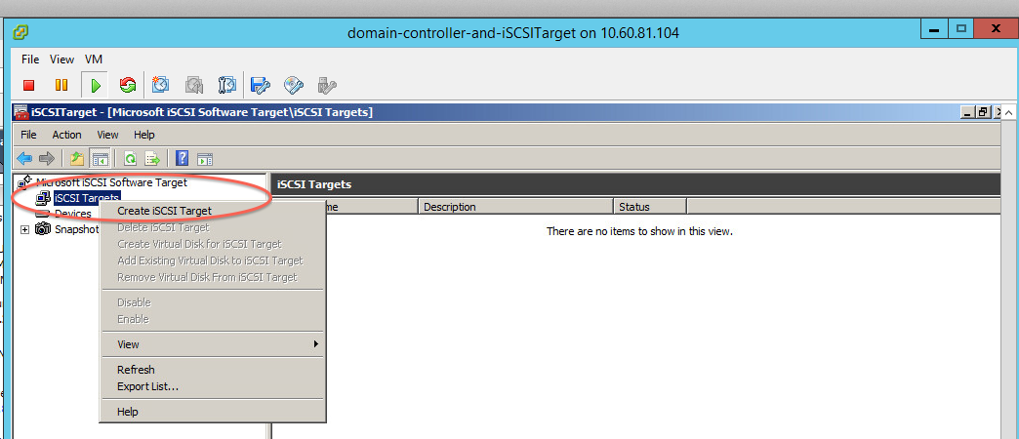

22) Give some name for target and click next (Description is optional)

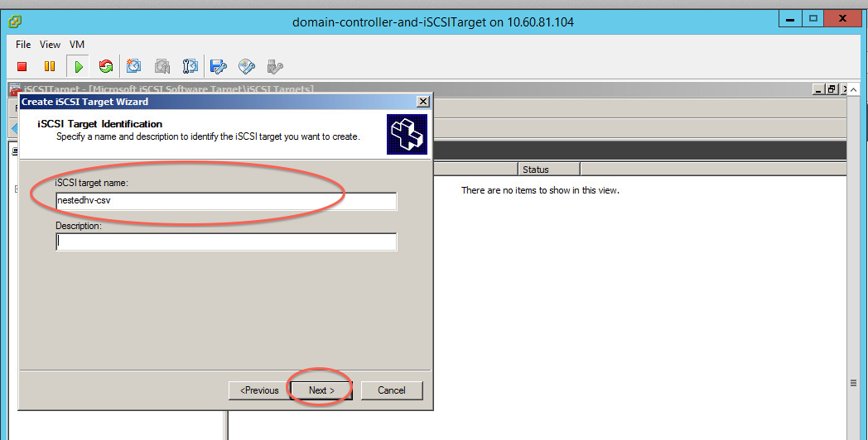

24) Right click on iSCSI target and select “Properties”

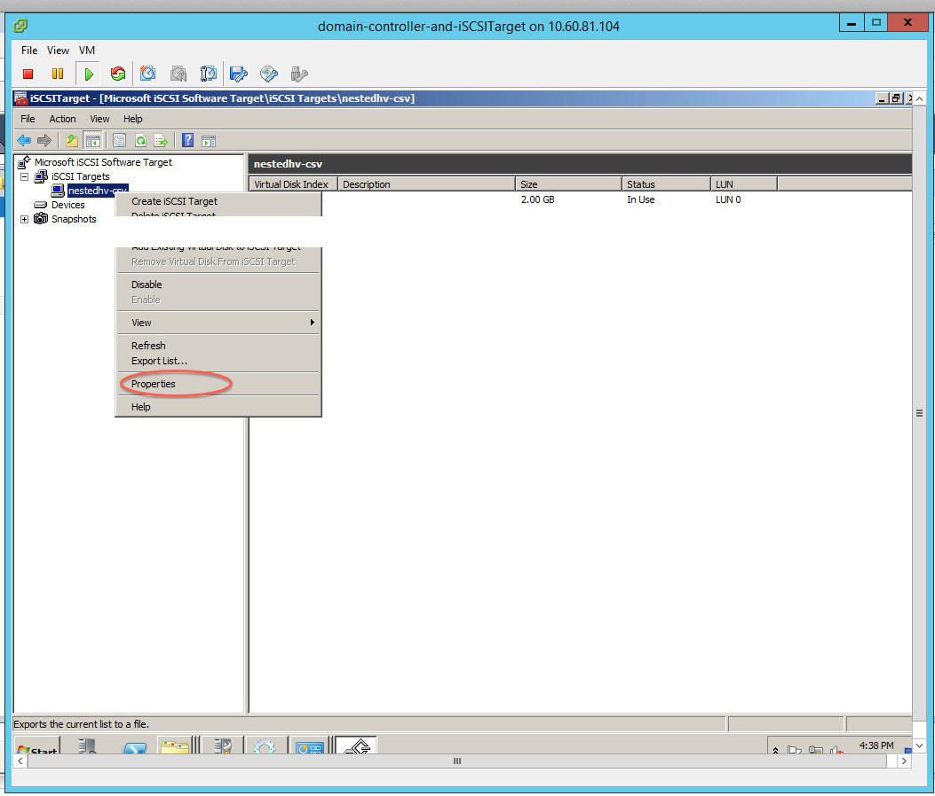

25) Give iSCSI initiator IP/IQN if you know, Otherwise just give ip of domain controller IP as of now(You will have to come back and change/add initiator ips). I know ip for one of Hyper-v so I am giving it here,

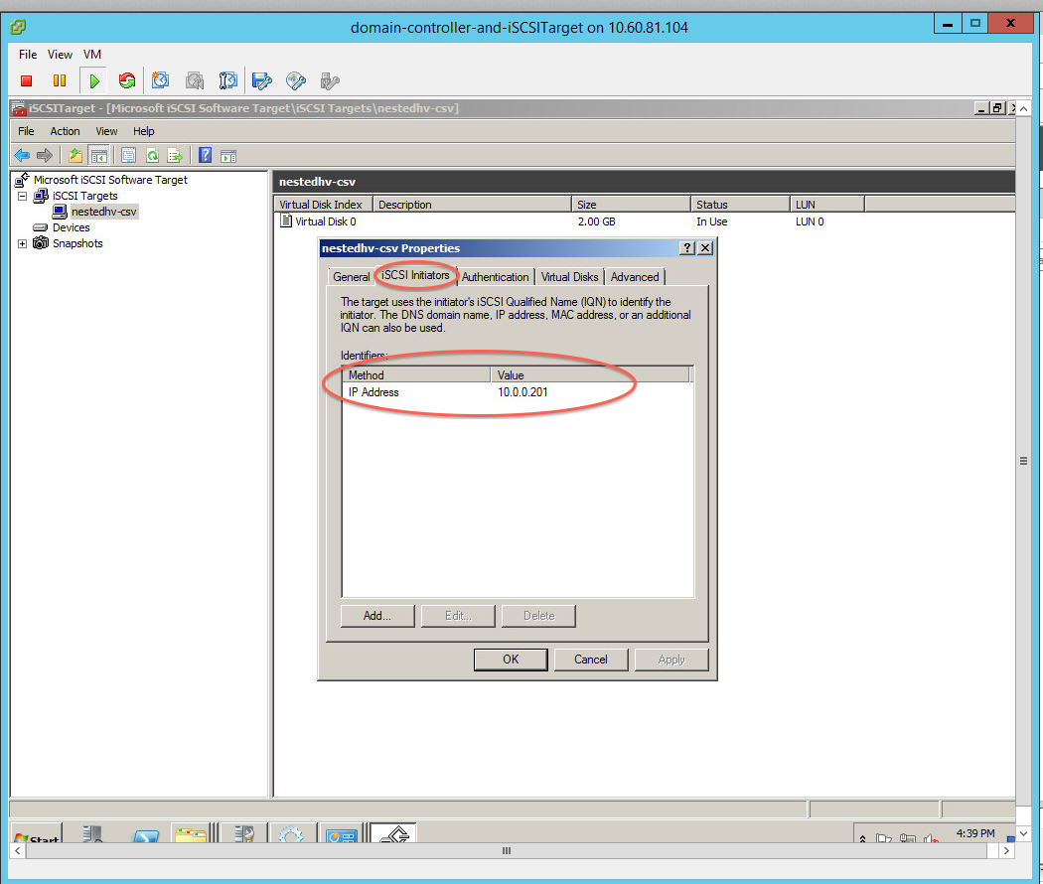

26) Give IQN so initiators (iSCSI target clients) can identify this server. IMO IP is best choice, I had hard time getting others to work.

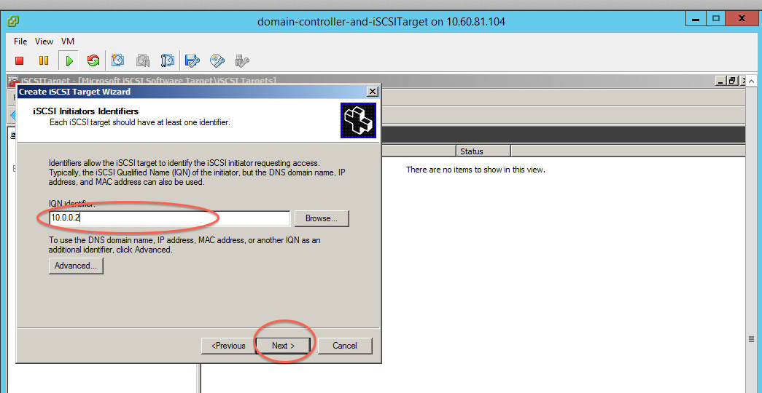

27) Lets create virtual disk. Right click on “Devices”, select “Create Virtual Disk”

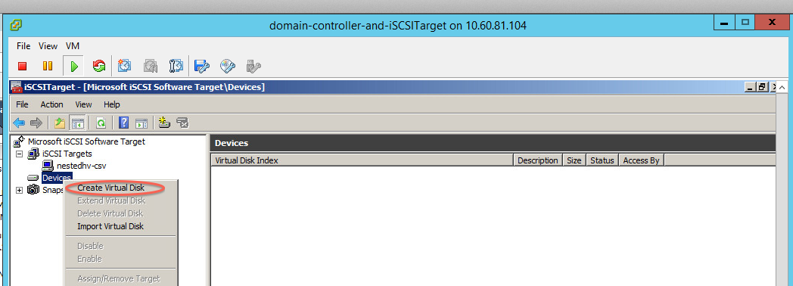

28) Select vDisk size depending on your VM requirements.

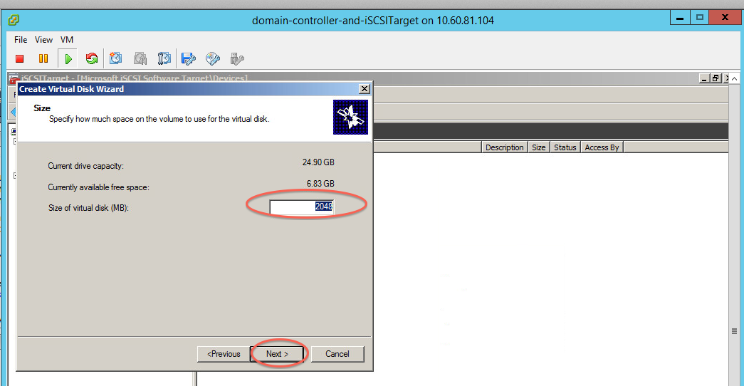

29) Add iSCSI target this disk will be part of,

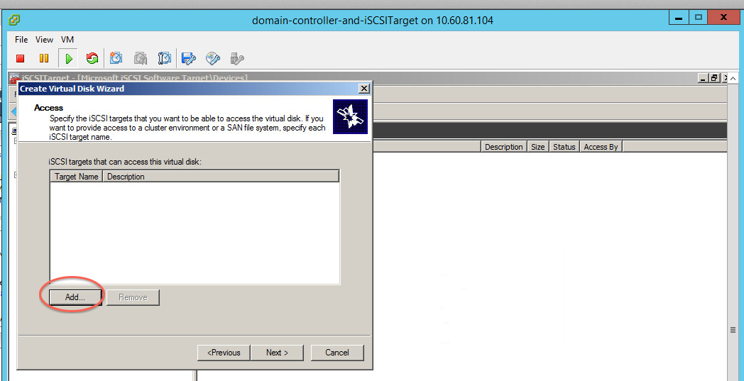

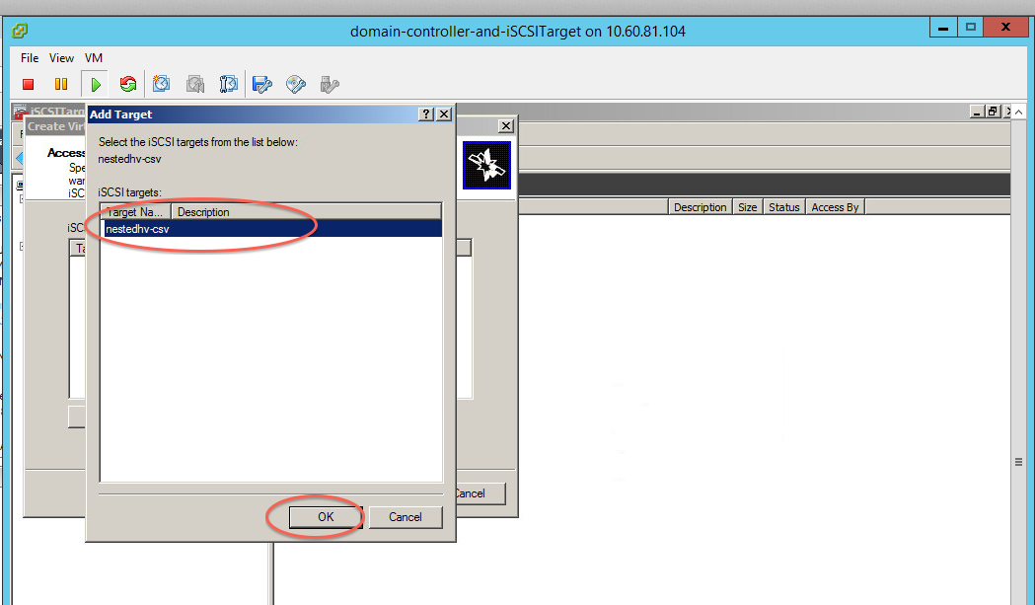

30) You will have to give file path where data for this vDisk will be stored. Verify disk is added.

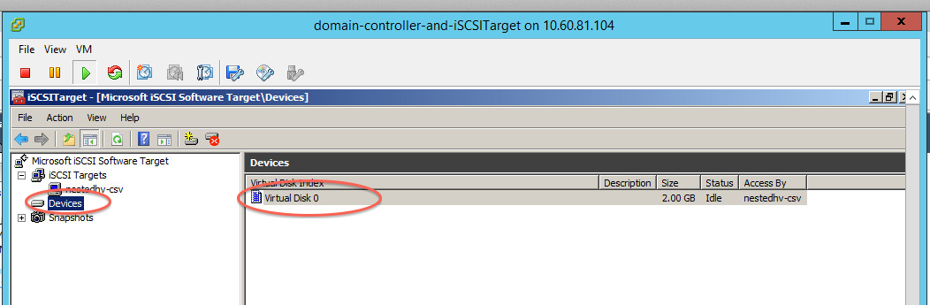

31) Lets make hyper-vs part of private network. Change IPs as per your domain controller

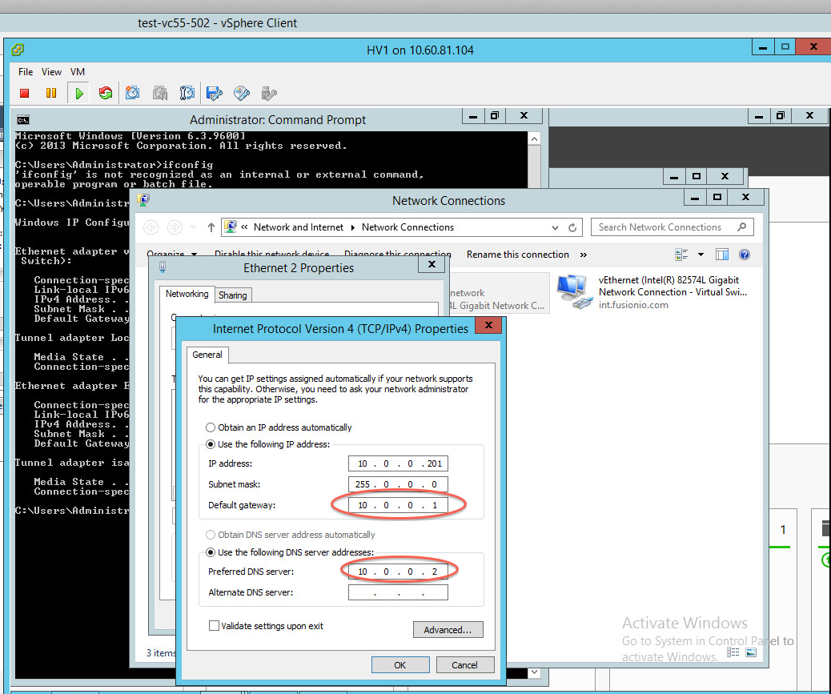

Make machine member of private domain

Open System properties and click “Change settings”

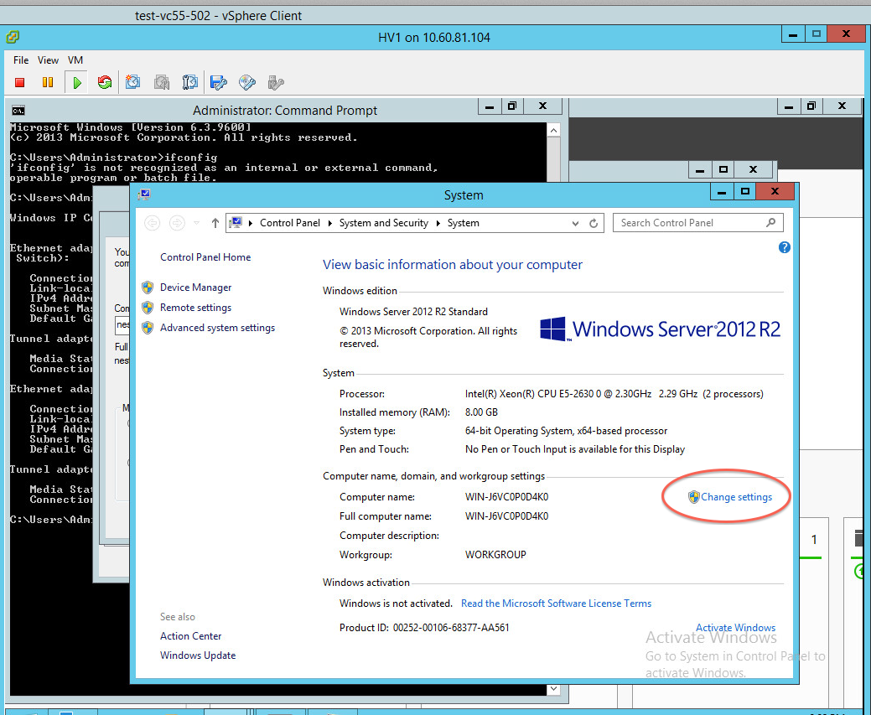

Specify hostname and domain details(You will have to restart VM)

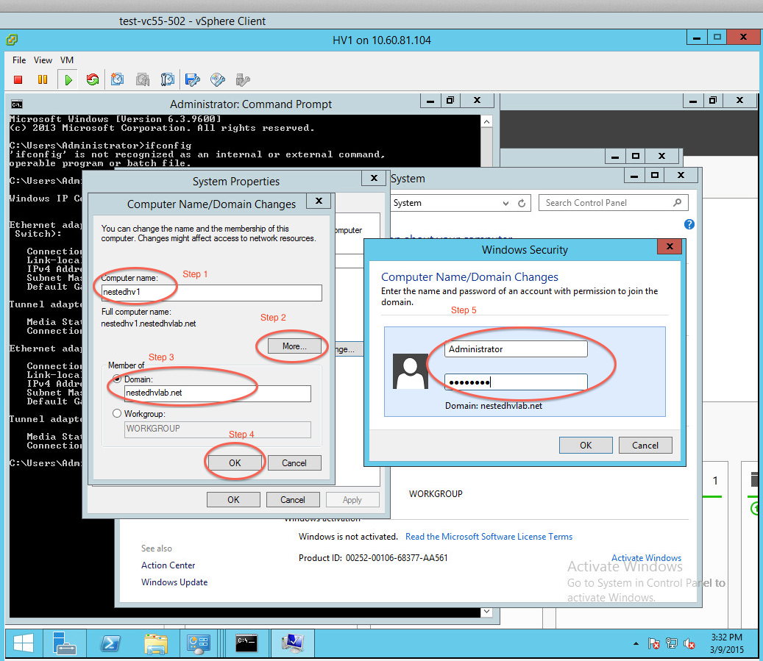

32) Install iSCSI client on both hyper-vs

Double click on MSI

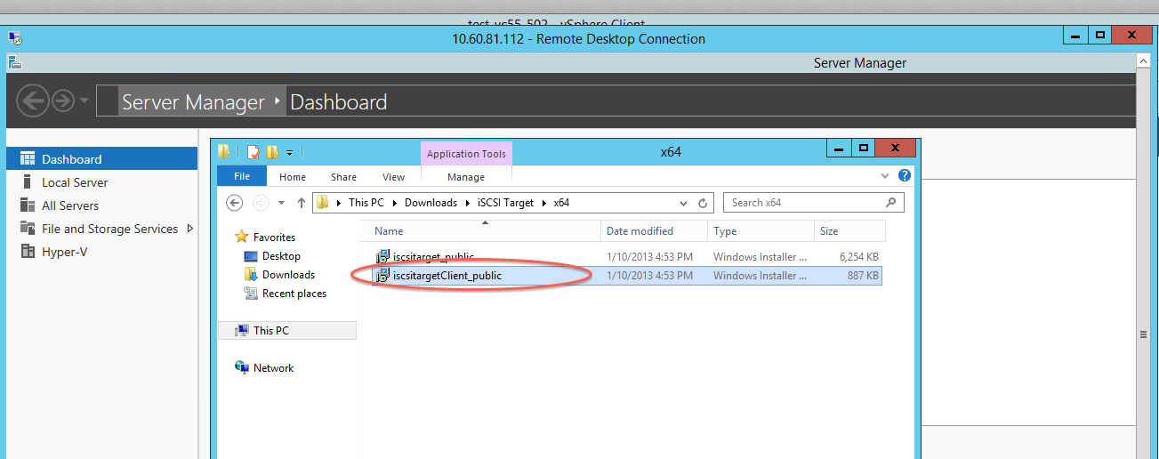

Give user credentials of local Administrator

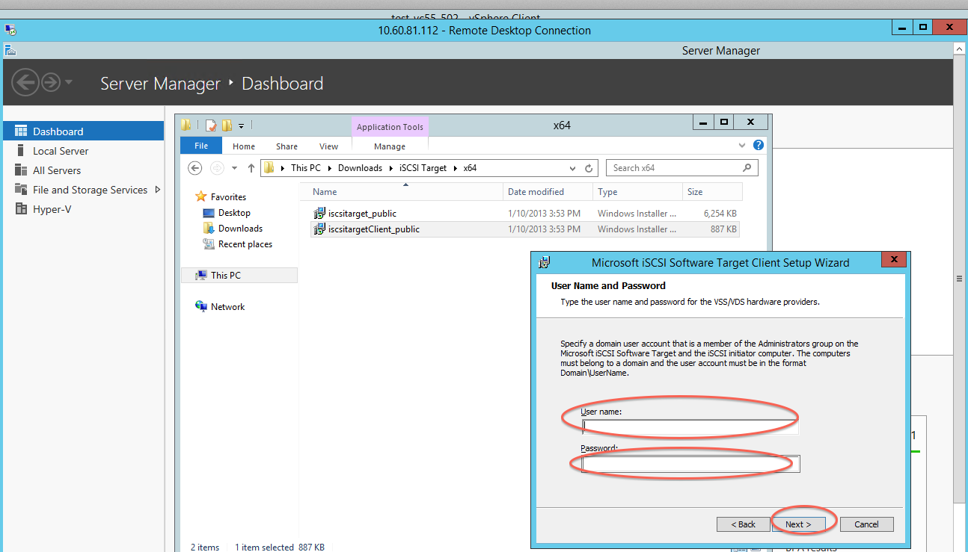

Once installed open iSCSI initiator,

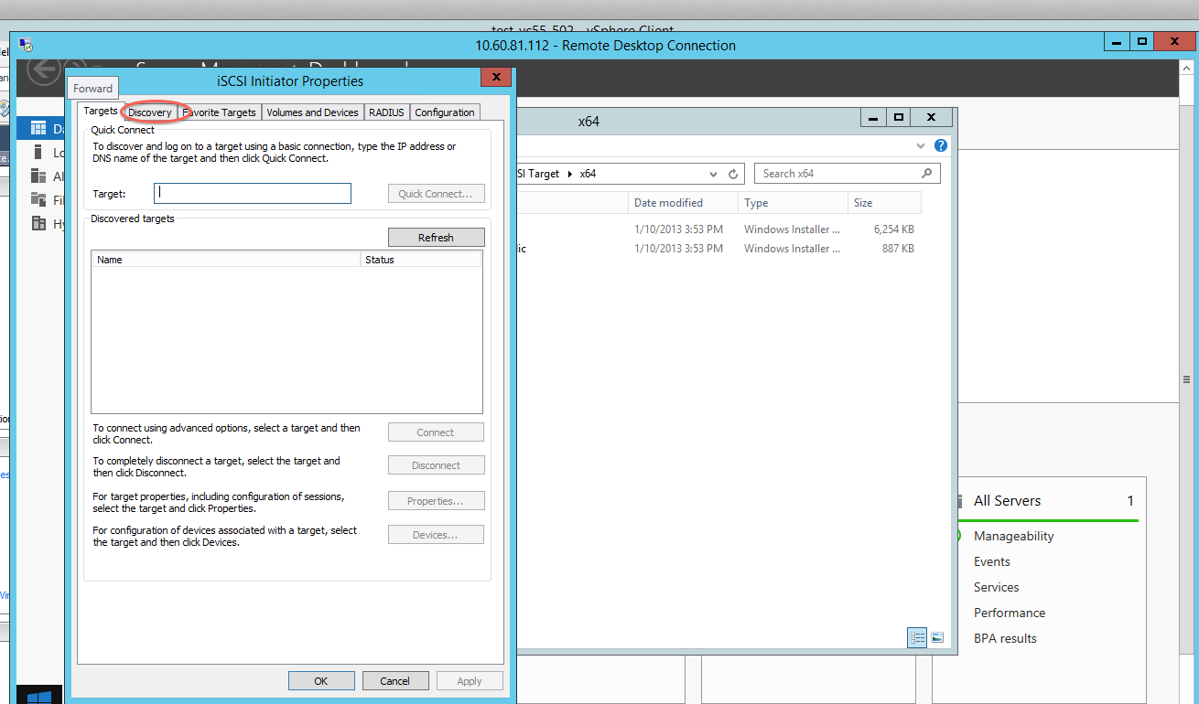

Select Discover tab,

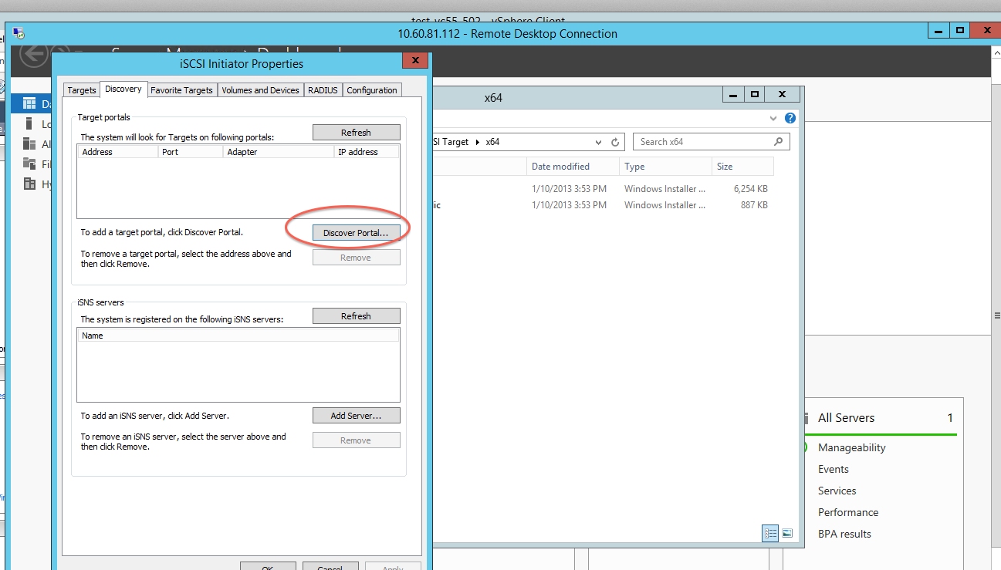

Give iSCSI Target IP or DNS name (In this case 10.0.0.2) and click on “Advanced”

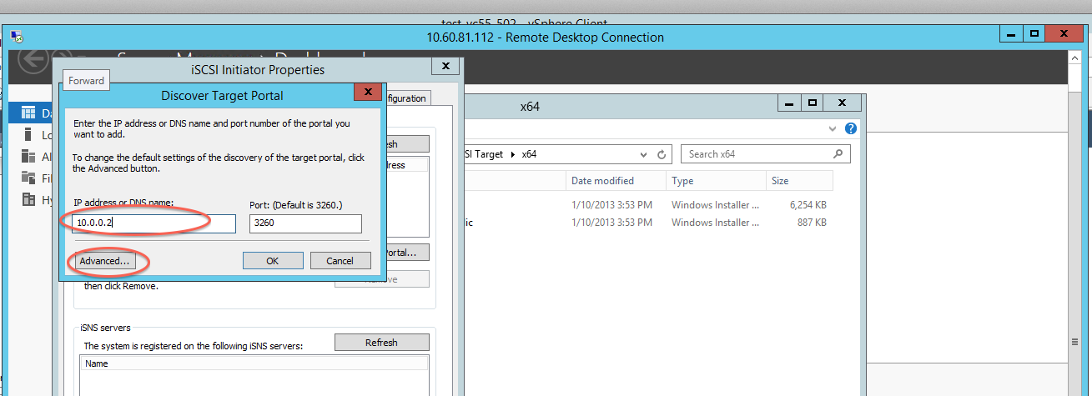

On next screen change local adapter to iSCSI initiator, provide initiator IP and click Ok

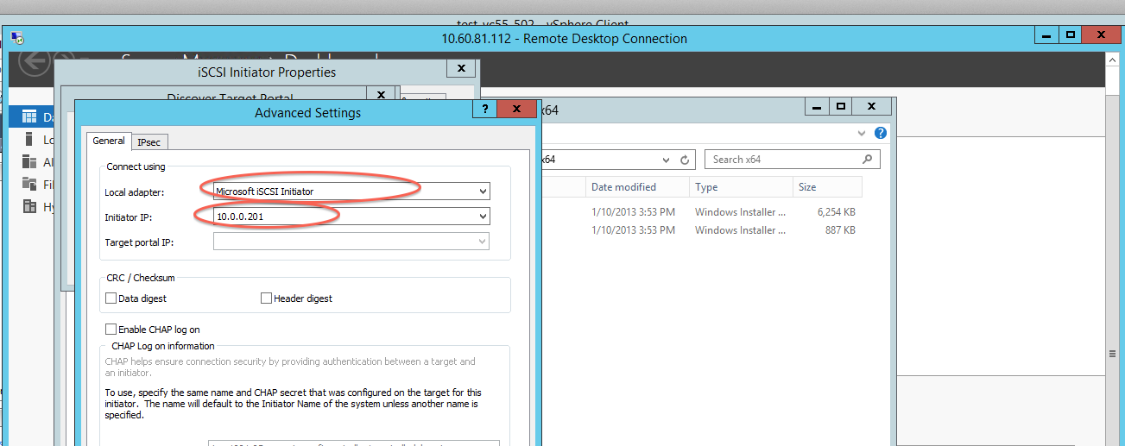

On initiator tab, type target IP or DNS name(In our case 10.0.0.2) and hit quick connect. This will establish connection between this initiator and target.

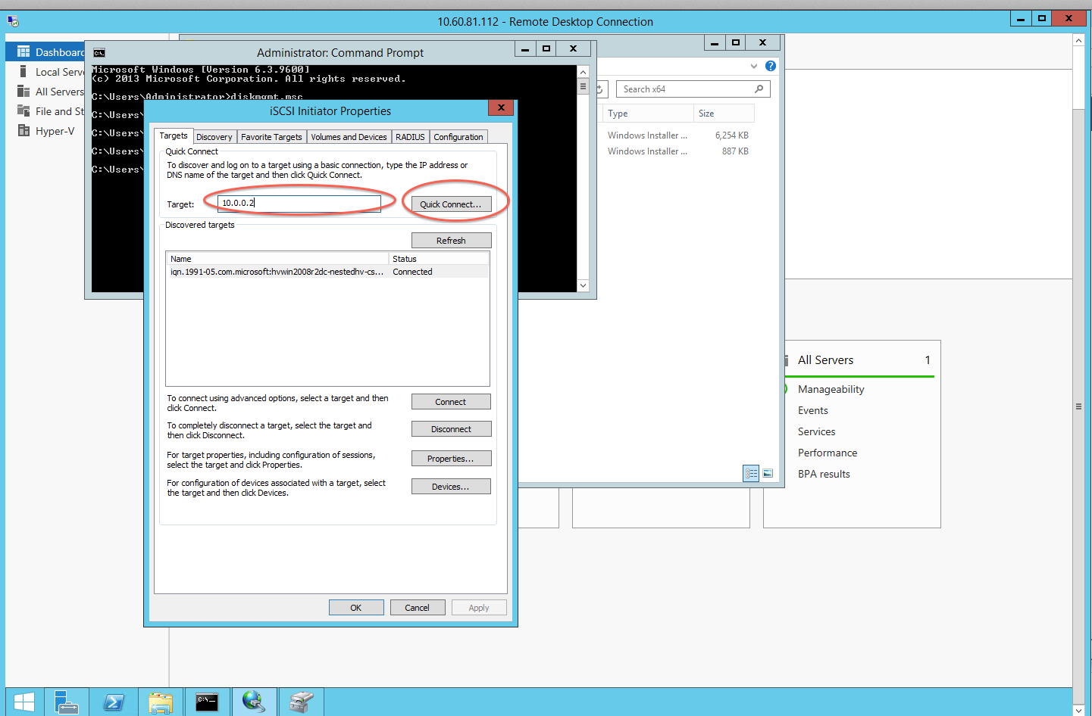

Upon successful creation you will be able to see disk,

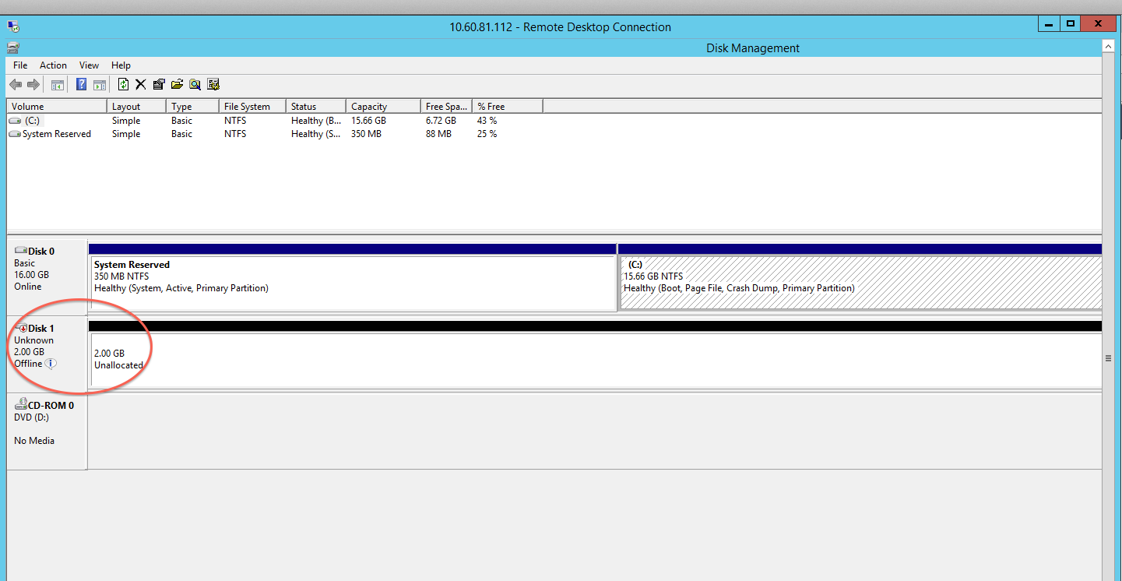

Please repeat step 31 and 32 for second hyper-v as well.

Once you are done with all steps, you can go ahead with creating cluster, add CSV. Please go online and use Microsoft online resources to learn how to create cluster.

References:

* Install hyper-v VM <http://www.derekseaman.com/2014/06/nesting-hyper-v-2012-r2-esxi-5-5.html>
* Upgrade vmware version <http://kb.vmware.com/selfservice/microsites/search.do?language=en_US&cmd=displayKC&externalId=1010675>

***How to deploy?***

Once you deploy ESXi template and power it on, wait until you get DHCP IP. Then add domain controller VM and hyper-v VM as before. Power on domain controller first so hyper-vs will get IPs later.